Greystones Patient Participation Group
Patient Observation and Suggestion Form

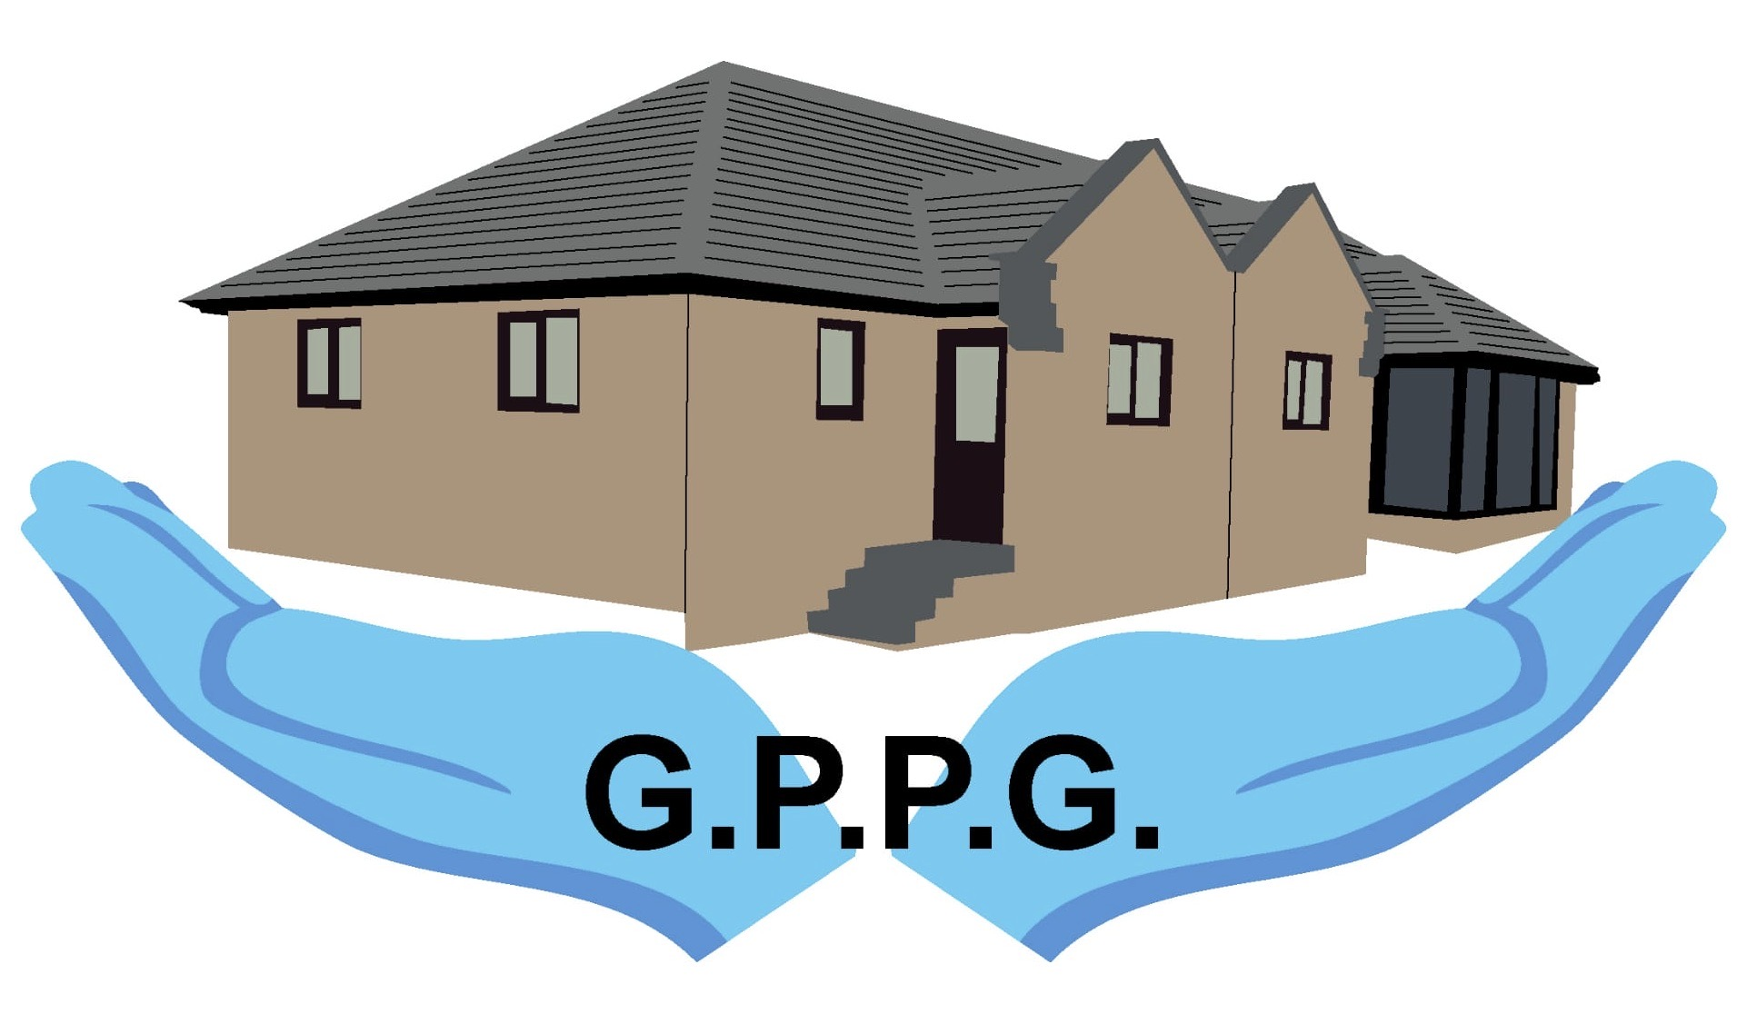

Greystones Patient Participation Group (GPPG) greatly values patient observations and suggestions regarding their experience at Greystones Medical Centre.
Please complete this form if you wish to pass an observation or suggestion onto GPPG. Please note individual patient complaints or medical issues should only be discussed with the Practice and not with GPPG.
Please date your form so that we know when it was submitted, and then hand to reception. If you do not wish reception to see your form, please ask for an envelope.
All forms will be treated in confidence and passed to a GPPG officer.
You can also email an Observation or Suggestion to: gmcppg2@outlook.com
GPPG officers will protect your anonymity. If, however, you are happy for your identity to be shared with the GPPG please tick here ☐
All forms and emails will be discussed at the next GPPG meeting. Thank you.

Name ............................................. (Optional) Date ...............................

Scan the QR code to visit the GPPG page on Greystones Medical Centre Website

Patient Observation or Suggestion
………………………………………………………………………………………………………………………………………………………………………………………………………………………………………………………………………………………………………………………………………………………………………………………………………………………………………………………………………………………………………………………………………………………………………………………………………………………………………………………………………………………………………………………………………………………………………………………………………………………………………………

